**March 2014**

**Volume 1, Issue 3**

Environmental Protection Program

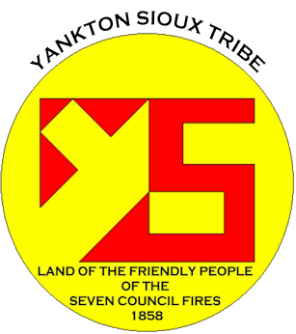

## Environmental Protection Agency-Tribal Environmental Plan (ETEP)

The Yankton Sioux Tribe Environmental Protection Program volunteered to be one of the 6 pilot tribes to develop an ETEP according the new GAP Guidance that was issued in 2013. YST EPP has been working endlessly with the Federal Environmental Protection Agency out of Denver, Co to develop an ETEP designed specifically for the Yankton Sioux Tribe. The six tribes that volunteered to be part of the designing of the ETEP are: Yankton Sioux Tribe, Lower Brule Sioux Tribe, Oglala Sioux Tribe, Blackfeet Nation, Ute Mountain Ute and Southern Mountain Ute.

ETEP’s will be developed to target the individual uniqueness of each Tribe’s environmental issue.

The Environmental Protection Program traveled to Denver, CO March 17th – 21st, 2014 for the quarterly Regional-Tribal Operations Committee meeting. Environmental issues are nationwide, and here in Region 8 the R-TOC works hard to try and tackle each environmental issue from Tribe to Tribe.

The Environmental field is a wide range of topics that affect human health and our environment.

Every Tribe has its own unique Environmental concern. On our lands we deal with Solid Waste, Recycling, Concentrated Animal Feeding Operations (CAFO), and Brownfields and soon to come, Water Quality for FY 15. Other tribes in our Region have concerns with Fracking, Underground Injection Control, Climate Change, and many others. Every Tribe in Region 8 has an opportunity to host an R-TOC meeting. This year’s June R-TOC is hosted by the Flathead Tribe and will be held in Polson, Montana.

Region 8 R-TOC officers:

Chairperson: Mike Durglo, Confederated Salish and Kootenai Tribe

Vice-Chairperson: Dave Nelson, Cheyenne River Sioux Tribe

Secretary: Richard Leasure, Yankton Sioux Tribe

***Individual Highlights:***

Brownfields Program 2

Utilities Program 3

Solid Waste 4

Recycling 5

Earth Day 6

Environmental Protection Program

PO Box 1153

Wagner, SD 57380

Phone: (605) 384-5003

***Special Interest Articles:***

**• EARTH DAY coming up April 22, 2014**

**• YST Housing Authority to coordinate Earth Day with the EPP programs**

**• YST Utilities**

# Regional-Tribal Operations Committee

## 128 (a) Tribal Response Program/Brownfields

The Brownfields Program is in its second year. We have been employed with developing a cleanup for the Marty Indian School Guest House. To date, a Phase I and Phase II Assessment has been completed. The YST Brownfields Program initially had 3 properties assessed. The sites are St. Joseph’s, St. Katherine’s and the Guest House. The assessment process requires a historical investigation of the properties and field sampling. The field sampling activities help determine the type of contaminants, concentration level, and the spread of contamination. The Yankton Sioux Tribe 128 (a) Tribal Response/Brownfield’s Program is continuing to provide a Phase I and Phase II assessments. We encourage the public to participate in the selection process of these properties as well as public participation in the reporting of potential brownfields properties.

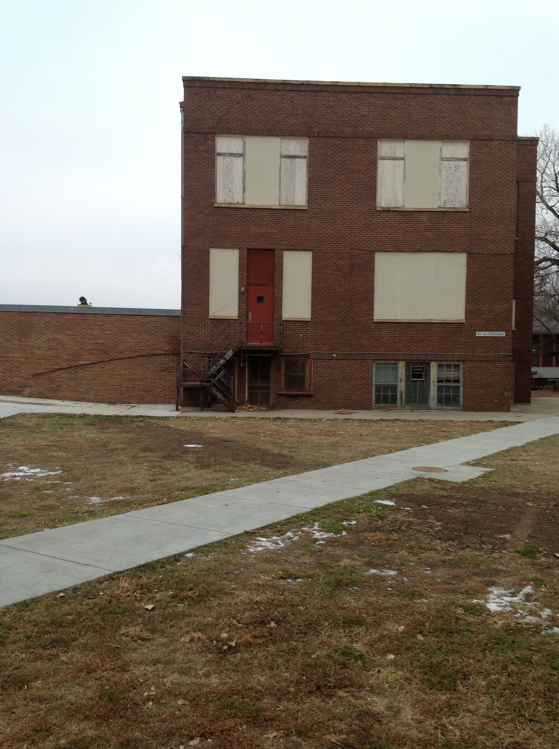

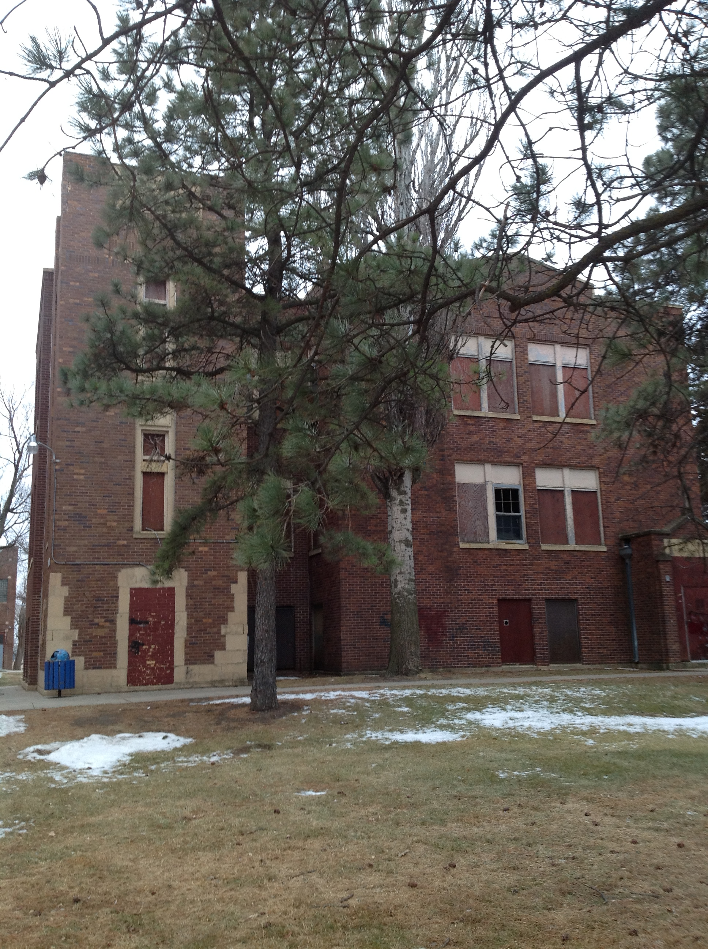

The addition of the Section 128(a) Tribal Response Program/ Brownfields funding has allowed the tribe to address the management and restoration of contaminated sites within Tribal lands.

Accomplishments to date:

* Completed a property inventory
* Created a Public record
* Conduct an investigation of Asbestos Contaminated Material, Lead Based Paint, Lead in Soil, PCB Light Ballasts
* Phase I and Phase II Assessments
* Currently preparing for a cleanup

## 128 (a) Tribal Response Program/Brownfields

St. Paul’s Mission was established in 1911 and assigned a resident priest in 1921. Being reliant upon money from the church and donors, the mission and school buildings were erected piecemeal as resources were available. The Guest House was built during the 1940’s. For those individuals that have been a part of St. Paul’s Mission, Marty Indian School and the Marty Community, know the buildings that have been erected on campus. The guest house is an L-shaped building with a sidewalk and a decorative brick wall. The history of Marty reaches far back and everyone that has been a part of the history of the campus should be heard on the basis of what should be done to these buildings. As part of the Yankton Sioux Tribe’s Brownfields Program process begins, the public opinion is included in the assessment process. Community input is a vital part of the YST Brownfields Program.

## Marty Indian School Former Guest House

“Protecting the human health and environment.”

## YST Utilities Program/Septic System Information

Septic systems are used when sewage treatment plants are not accessible. They safely treat and dispose of wastewaters produced in the bathroom, kitchen, and laundry. These wastewaters may contain disease-causing germs and pollutants that must be treated to protect human health and the environment. Although septic systems are usually a permanent solution to wastewater treatment and disposal, they sometimes serve as a temporary solution until sewer lines are installed.

Unlike a sewer system, which discharges treated wastewater into a body of water, the septic system depends on the soil around the home to treat and dispose of sewage effluent. For this reason, a septic system can be used only on soils that will adequately absorb and purify the effluent. If a septic system is installed in soil that cannot do so, the effluent will seep out onto the soil surface overlying the drain field. In addition to causing an unpleasant smell, this untreated effluent can pose health problems. The more water your family uses, the greater the likelihood of problems with the septic system. Septic systems will adequately absorb and purify wastewater if they are properly maintained. A few precautions can save you anguish and money. Reducing water use, avoiding grease, pumping the tank periodically, and properly landscaping the yard to keep surface water away from the tank and drain field are inexpensive precautions that can help assure your system a long life.

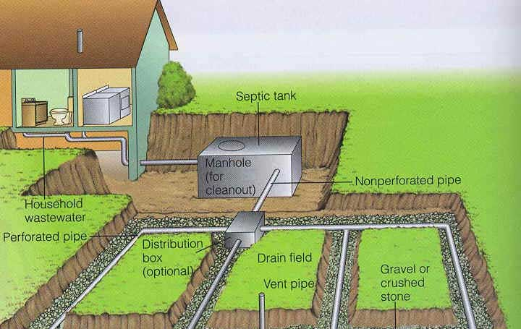

 A two-compartment septic system.

 A Septic Drain field

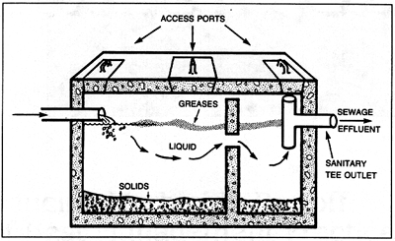

Buried beneath your back yard, it is out there – constantly working. When you’re at work, it is working. When you’re eating dinner, it continues working. And when you’re sleeping, it’s still out there in the dark – working. What is it? Your septic system. It may be the most overlooked and undervalued utility in your home; but with proper care and maintenance, your septic system can continue to work for you at least 25 to 30 years.

If you are like most homeowners, you probably never give much thought to what happens when waste goes down your drain. But if you rely on a septic system to treat and dispose of your household wastewater what you don’t know *can* hurt you.

Proper operation and maintenance of your septic system can have a significant impact on how well it works and how long it lasts, and in most communities, septic system maintenance is the responsibility of the homeowner.

Preventing groundwater pollution from failing septic systems should be a priority for every community and every homeowner. Contamination of the groundwater source can lead to the pollution of local wells, stream s, lakes, and ponds – exposing family, friends, and neighbors to waterborne diseases and other serious health risks.

When a septic system fails, inadequately treated domestic waste can reach the groundwater. Bacteria and viruses from human waste can cause dysentery, hepatitis, and typhoid fever. Many serious outbreaks of these diseases have been caused by contaminated drinking water.

In addition, a failing septic system can lead to unpleasant symptoms, such as pungent odors and soggy lawns.

 “Reducing water use, avoiding grease, pumping the tank periodically, and properly landscaping the yard to keep surface water away from the tank and drain field are inexpensive precautions that can help assure your system a long life.”

## Maintaining Your Septic System – A Guide For Homeowners

## Solid Waste

Every year, the United States generates approximately 230 million tons of “trash” – about 4.6 pounds per person per day. Less than one-quarter of it is recycled; the rest in incinerated or buried in landfills. With a little forethought, we could reuse or recycle more than 70% of the landfilled waste, which includes valuable materials such as glass, metal and paper. This would reduce the demand on virgin sources of these materials and eliminate potentially severe environmental, economic, and public health problems.

.How can we find ways to meet our current economic and social needs without compromising the ability of our childre3n, and our children’s children, to do the same? Our succe4ss will depend on understanding the difference between:

* Sustainable practices; practices that provide ongoing economic and social benefits without degrading the environment.
* Unsustainable practices: “quick fixes” that fill an immediate need for resources. Over time, however, these practices deplete or damage natural resources so they cannot be used or enjoyed by future generations.

“With a little forethought, we could reuse or recycle more than 70% of the landfilled waste”

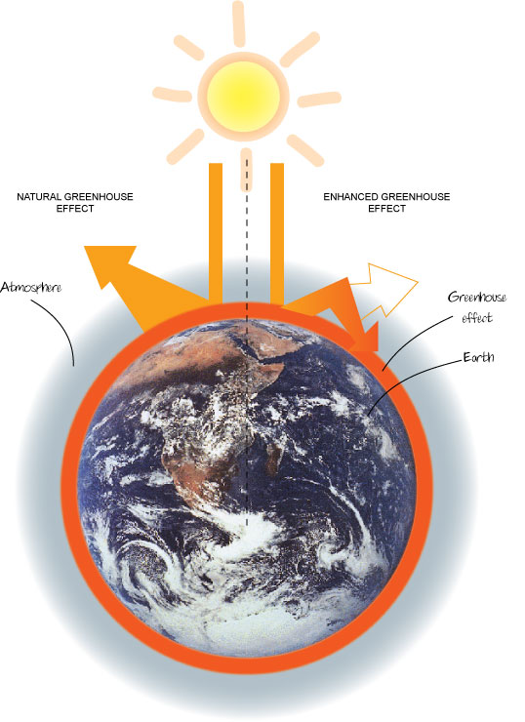

## Solid Waste Management and Climate Change

“Solid waste also impacts climate change”

The Yankton Sioux Tribe Environmental Protection Program in conjunction with the YST Utilities/Solid Waste Program are working to develop an Integrated Solid Waste Management Plan.

While it is generally understood that proper waste management helps protect human health and the environment and preserve natural resources, many do not realize that solid waste also impacts climate change. The manufacture, distribution, and use of products – as well as the disposal of the resulting waste – all result in emission of atmospheric gasses called “greenhouse gases” that affect the Earth’s climate. When organic waste decomposes in landfills and uncontrolled dumps, it produces methane one of the major greenhouse gases contributing to climate change. Waste generation increases with population expansion and industrialization. You can reduce greenhouse gas emissions, however, through proper solid waste management.

Solid waste should be managed through a number of activities-waste prevention, recycling, composting, controlled burning, or landfilling.

These uses are the backbone to a concrete Integrated Solid Waste Management Plan.

An ISWMP can help reduce greenhouse gas emissions and slow the effects of climate change. .

.

## Recycling

The benefits of recycling go far beyond the materials we keep out of the landfill. Overall, recycling can:

* Conserve resources for the future.
* Prevent emissions of many greenhouse gases and water pollutants.
* Save energy
* Supply valuable raw materials to industry
* Create jobs
* Stimulate the development of greener technologies
* Reduce the need for new landfills and incinerators.
* Every ton of paper recycled a year save 17 trees and 7000 gallons of water
* Methane is the second largest source of greenhouse gas in the atmosphere, and landfills account for 37% of methane gas output. By reducing and recycling properly organic materials, including paper, we can divert them from landfill, thereby reducing anaerobic decomposition and the production of methane gas.
* Recycling one aluminum can saves enough energy to run a TV for three hours

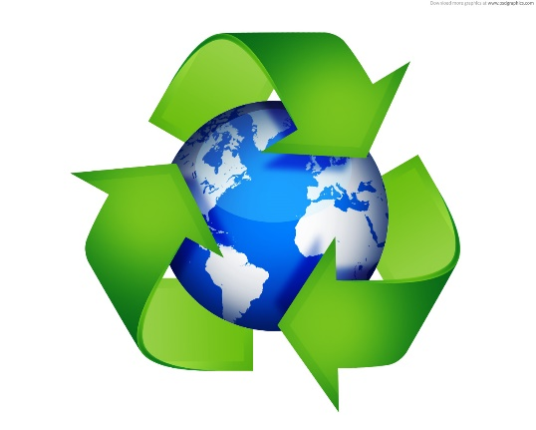

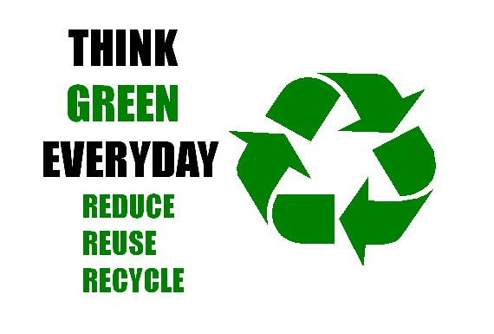

**Who recycles in our local area:**

* Marty Indian School
* Marty Indian School Student Council
* Indian Health Service
* Yankton Sioux Tribe Travel Plaza
* Fort Randall Casino/Hotel
* Yankton Sioux Tribal Program

**What We Recycle:**

* Paper
* Cardboard
* Newspaper
* Plastic Bottles
* Metal Cans
* Aluminum Cans

**When Do We Recycle:**

**9:00AM – 4:00PM**

**Monday – Friday**

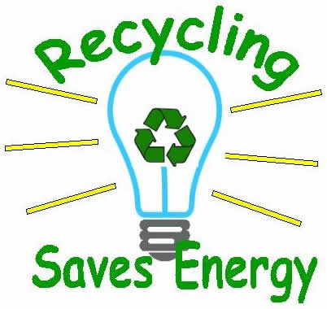

“If you're not buying recycled products, you're not really recycling.”

## YST Recycling Program

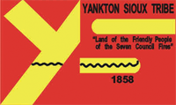

April 22, 2014 is Earth Day. Here at the Yankton Sioux Tribe Environmental Protection Program, we have already started preparing.

Last year snow storms inhbited our ability to provide an attendance for Earth Day. This year we are anticipating good weather and a large number of participants.

To date we have contacted:

* All YST Tribal Programs.
* Indian Health Service,
* Yankton Sioux Housing Authority,
* Fort Randall Casino and
* Marty Indian School

So far, we have had a positive response from everyone.

If you would like to help, please contact the Environmental Protection Program.

We hope that the weather cooperates this year!!!

Hope to see you there!

## *Coming Soon!!!!*

## EARTH DAY

## April 22, 2014

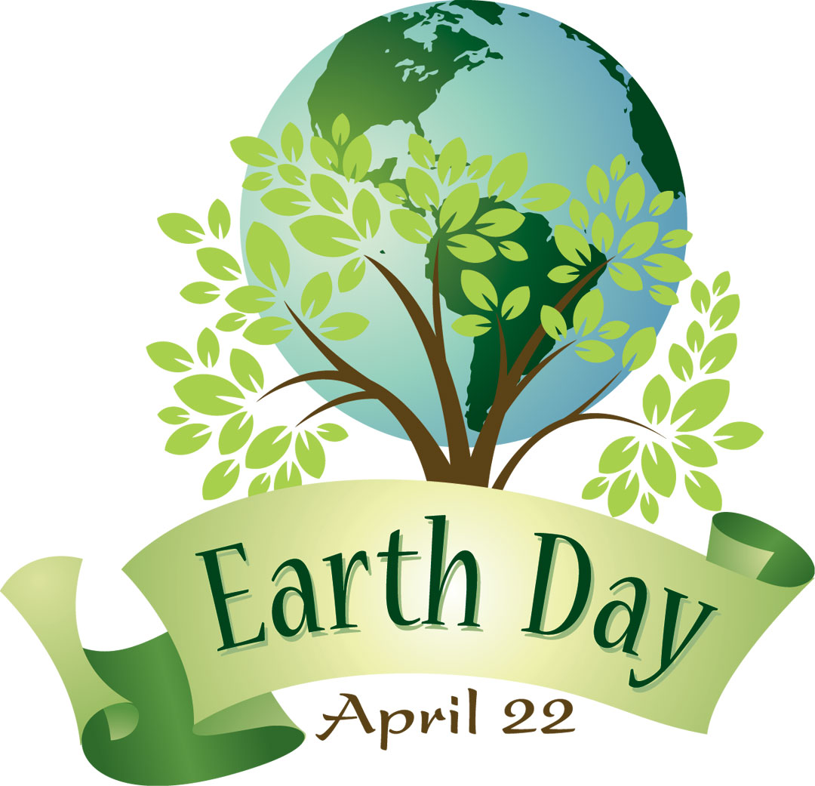

#### About Our Organizations…

**Environmental Protection Program/General Assistance Program**

Mr. Richard Leasure

EPP/GAP Director

Miss Olivia Munoz

EPP/GAP Tech.

Phone: (605) 384-5003

Fax: (605) 384-5006

**128 (a) Tribal Response Program/Brownfields**

Ms. Danielle Zephier

Brownfields Coordinator

Phone: (605) 384-5003

Fax: (605) 384-5006

**YST Utilities Program**

Mr. Bryan Heth

Utilities Manager

Mr. Sheldon Powers

Solid Waste Disposal Technician

Phone: (605) 384-5003

Fax: (605) 384-5006



